**Static Learning- Prerequisites.**

**Objectives:**

* Student Understand the search project of PacMan and where to write the code to navigate the pacman.
* Demonstrate ethical and professional responsibilities involved in completion of Tasks

**Rubric A: Cognitive Domain**

|  |  |  |  |  |  |  |
| --- | --- | --- | --- | --- | --- | --- |
| **CLO** | **0** | **1** | **2** | **3** | **4** | **5** |
| CLO1 | Student not able to run the pacman code | Student understand where to write the code for actions | The pacman is navigating but not reaching at goal for any single maze | The pacman is navigating and reaching at the goal for atleast one maze | The pacman is navigating and reaching at the goal for atleast two maze | The pacman is navigating and reaching at the goal for all mazes |

**Introduction**

In this project, you shall help pacman to find path through his maze world by giving him a list of actions. These Actions shall be calculated by you and pacman only execute those action.

**PacMan Project Details**

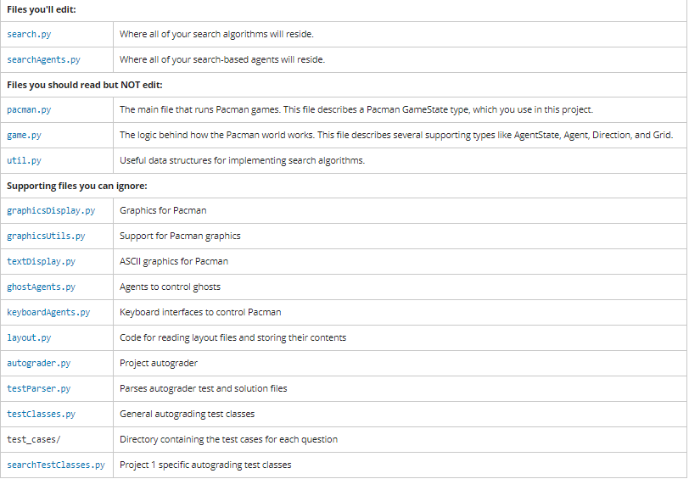

**File and Function to Edit**

**In this lab, all your code shall be written in the search.py file.**

### Welcome to Pacman

After downloading the code ([search.zip](https://s3-us-west-2.amazonaws.com/cs188websitecontent/projects/release/search/v1/001/search.zip)), unzipping it, and changing to the directory (or if it is unzip go to search folder directly), you should be able to play a game of Pacman by typing the following at the command line:

python pacman.py

Pacman lives in a shiny blue world of twisting corridors and tasty round treats. Navigating this world efficiently will be Pacman's first step in mastering his domain.

The simplest agent in “**searchAgents.py**” is called the “GoWestAgent”, which always goes West (a trivial reflex agent). This agent can occasionally win:

python pacman.py --layout testMaze --pacman GoWestAgent

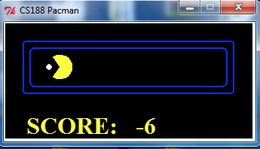

python pacman.py --layout tinyMaze --pacman GoWestAgent

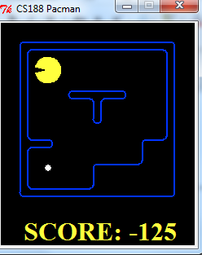

If Pacman gets stuck, you can exit the game by typing CTRL-c into your terminal.

Note that pacman.py supports a number of options that can each be expressed in a long way (e.g., --layout) or a short way (e.g., -l). You can see the list of all options and their default values via:

python pacman.py -h

In searchAgents.py, you'll find a fully implemented SearchAgent, which plans out a path through Pacman's world and then executes that path step-by-step. The search algorithms for formulating a plan are not implemented -- that's your job.

First, test that the SearchAgent is working correctly by running:

python pacman.py -l tinyMaze -p SearchAgent -a fn=tinyMazeSearch

The command above tells the SearchAgent to use tinyMazeSearch  function as its search algorithm, which is implemented in search.py. Pacman should navigate the maze successfully.

**Question 1:** Find the search pattern for mediumClassicMaze. Your task is two find a search pattern Pacman should eat at least one of his food successfully when you run following command

python pacman.py -l mediumClassic -p SearchAgent -a fn=mediumClassicSearch

you need to add code under function mediumClassicSearch inside the search.py

**Question 2:**

python pacman.py -l mediumMaze -p SearchAgent -a fn=mediumMazeSearch

**Question 3:**

python pacman.py -l bigMaze -z .5 -p SearchAgent -a fn=bigMazeSearch